
A STUDY ON HUMAN RESOURCE MANAGEMENT
PRATICES FOR INDUSTRIAL DEVELOPMENT
IN
EXPERT MARITIME SERVICES


By
DINESH KUMAR K
(Reg.No.310819631013)

A PROJECT REPORT
Submitted to the
FACULTY OF MANAGEMENT SCIENCES
In partial fulfilment for the award of the degree
Of
MASTER OF BUSINESS ADMINISTRATION
ANNA UNIVERSITY
CHENNAI 600 025
AUGUST, 2021

JEPPIAAR ENGINEERING COLLEGE
JEPPIAAR NAGAR, RAJIV GANDHI ROAD,
CHENNAI - 600119.
DEPARTMENT OF MANAGEMENT STUDIES

BONAFIDE CERTIFICATE
Certified that this project report titled “ A STUDY ON HUMAN RESOURCE MANAGEMENT PRATICES FOR INDUSTRIAL DEVELOPMENT IN EXPERT MARITIME SERVICE CHENNAI ,is the bonafide work of Mr.DINESH KUMAR K, Registration Number: 310819631013 who carried out the research under my supervision. Certified further , that to the best of my knowledge the work reported here in does not form part of any other project report or dissertation on the basis of which a degree or award was conferred on an earlier occasion on this or any other candidate

SIGNATURE OF SUPERVISOR SIGNATURE OF HOD
SUBMITTED TO PROJECT VIVA VOICE HELD ON ……………….

INTERNAL EXAMINER EXTERNAL EXAMINER
DECLARATION
I hereby declare that the Project Report titled “A STUDY ON HUMAN RESOURCE MANAGEMENT PRATICES FOR INDUSTRIAL DEVELOPMENT IN EXPERT MARITIME SERVICES, CHENNAI” Submitted for M.B.A Degree is my original work and the dissertation has not formed the basis for the award of any degree, associate ship, fellowship or any other similar titles.

Place: CHENNAI
Date:
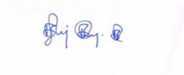
Signature of the Student
(DINESH KUMAR K)

CERTIFICATE
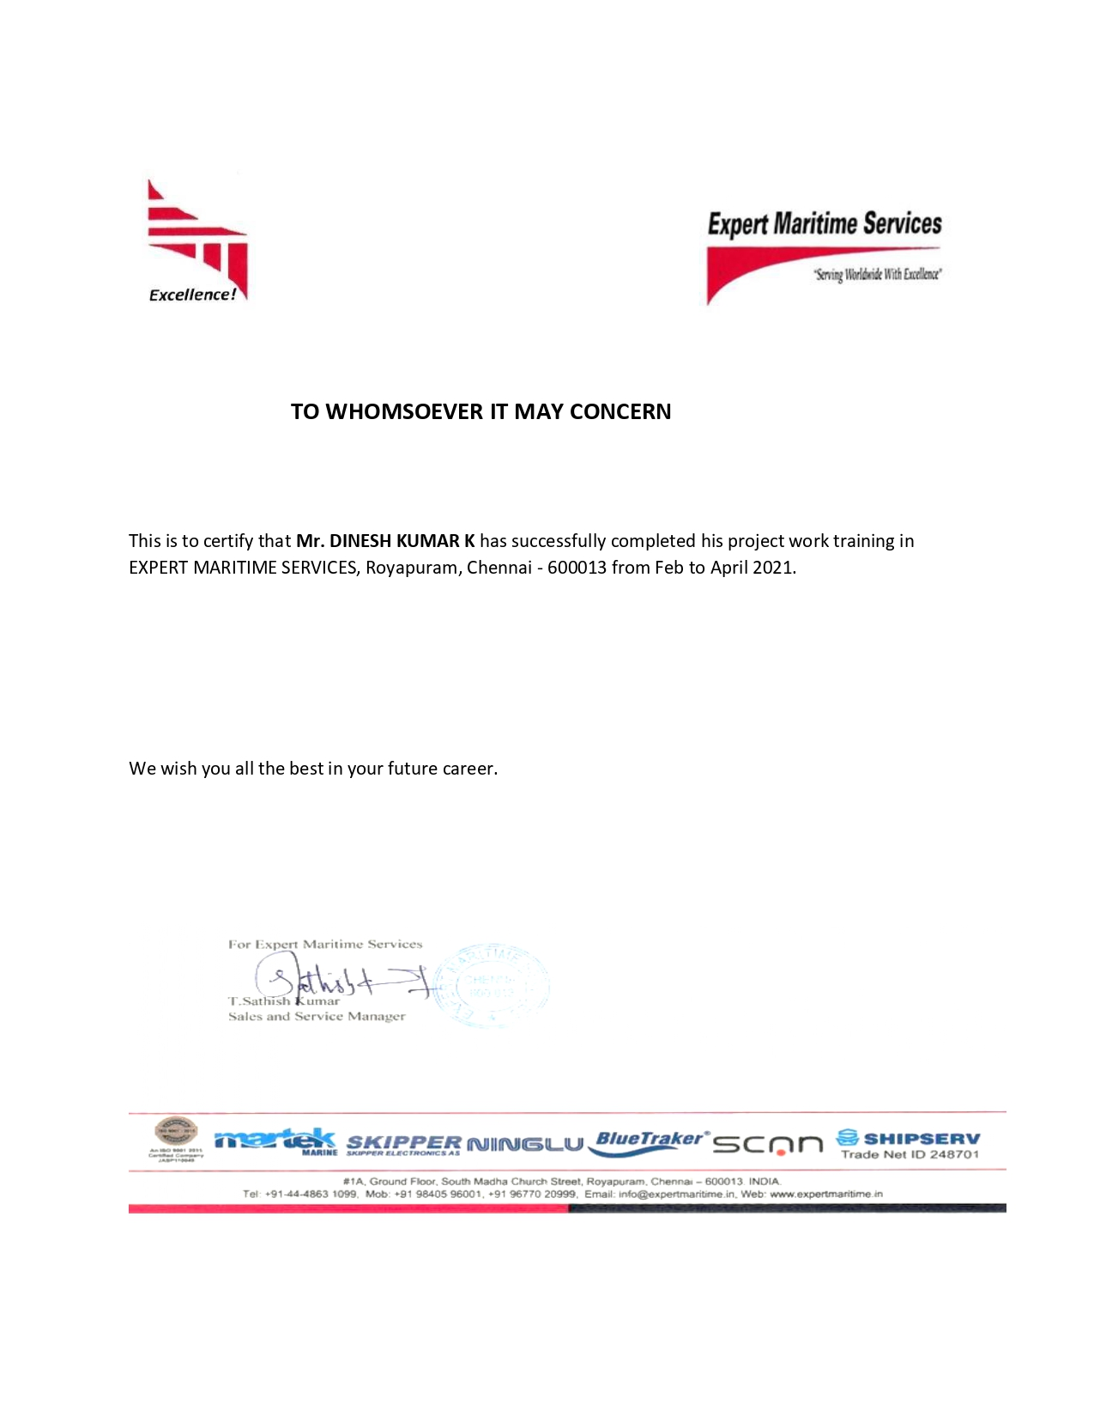

ACKNOWLEDGEMENT

With the blessings of our Founder Chairman (Late) Col.Dr.JEPPIAAR M.A., B.L., Ph.D., this project work is done, as a part of the curriculum of MBA, affiliated to Anna University.
We are very much indebted to the Chairman and Managing Director Dr.M.Regeena Jeppiaar, B.tech, M.B.A., Ph.D., and the Principal Dr.V.Natarajan , M.E .,Ph.D., and Dr.N.Padmavathy, M.B.A., M.Phil., Ph.D., Head of department-MBA.
I would like to express our deep sense of gratitude to our guide Dr.Gopi Ethiraj, MBA, for giving valuable suggestions for making this project a grand success.
I take this opportunity to express our sincere gratitude to our external guide
Mr. SATHISH KUMAR .T Manager of EXPERT MARITIME SERVICES, Chennai for giving us the opportunity to do this project under his esteemed guidance.
I also thank the teaching and non-teaching staff members of the Department of Management of Studies for their constant support.

ABSTRACT
This motivation behind the investigation is to inspect the adequacy of human asset the executives rehearses in improving the modern agreement in the association. The business who has a responsibility of making major hierarchical arrangements needs to accomplish corporate targets must assume a predominant job in guaranteeing modern harmony. The motivation behind the investigation is to inspect whether the HRM rehearses are adequate and compelling for the mechanical amicability of EMS. This investigation analyzes the effect on human resource practices on the board practices for modern concordance. An example of 141 samples has been collected from the EMS from various sectors of the division. The outcome of the study states that the organization is providing efficient Human resource management practices that are required and mandatory for the organization. HRM practices that has been followed by EMS is in the developmental stage of the organization. When analyzes states the effective HRM practices that will be helpful for the industrial development.

TABLE OF CONTENTS
CHAPTER No. | TITLE | PAGE No.
 | Acknowledgement | 4
 | Certificate | 5
 | Abstract | 6
1 | INTRODUCTION
1.1 | INTRODUCTION OF THE STUDY | 10
1.2 | INDUSTRY PROFILE | 11
1.3 | COMPANY PROFILE | 12
1.4 | PRODUCT PROFILE | 13
2 | LITERATURE SURVEY
2.1 | THEORETICAL REVIEW | 14-16
3 | RESEARCH DESIGN
3.1 | RESEARCH METHODOLOGY | 17
3.2 | STATEMENT OF THE PROBLEM | 17
3.3 | OBJECTIVES OF THE STUDY | 17
3.4 | DESIGN | 17-18
3.5 | SOURCE & TOOLS FOR DATA COLLECTION | 18-19
3.6 | TOOLS FOR DATA ANALYSIS | 19
3.7 | LIMITATIONS | 19
4 | DATA ANALYSIS & INTERPRETATION
4.1 | DATA ANALYSIS | 20-48
5 | FINDINGS, SUGGESTIONS & CONCLUSION
5.1 | FINDINGS OF THE STUDY | 49-51
5.2 | SUGGESTIONS | 52
5.3 | CONCLUSION | 53
 | ANNEXURE | 54-56

LIST OF TABLES
S.NO | TABLES | PG.  NO
 | FREQUENCY
4.1 | GENDER OF THE RESPONDENTS. | 20
4.2 | DEPARTMENT OF THE RESPONDENTS | 21
4.3 | AGE OF THE RESPONDENTS | 22
4.4 | EXPERIENCE OF THE RESPONDENTS. | 23
4.5 | HEALTH OF THE RESPONDENTS | 24
4.6 | HEALTH AND SAFETY OF RESPONDENTS | 25
4.7 | RECRUITMENT AND SELECTION OF THE RESPONDENTS | 26
4.8 | FAVOURITISM OF THE RESPONDENTS. | 27
4.9 | INTERVIEW PANELS OF THE RESPONDENTS. | 28
4.10 | ATTENTION OF THE RESPONDENTS. | 29
4.11 | EMPLOYERS SUPPORT OF THE RESPONDENTS | 30
4.12 | EQUALITY IF THE RESPONDENTS | 31
4.13 | ENCOURAGEMENT OF THE RESPONDENTS | 32
4.14 | TRAINING OPPORTUNITIES OF THE RESPONDENTS | 33
4.15 | TRAINING AND DEVELOPMENT OF THE RESPONDENTS | 34
4.16 | ORGANIZATION COMMITMENT OF THE RESPONDENTS | 35
4.17 | FAITH IN THE PERFORMANCE OF THE RESPONDENTS | 36
4.18 | JOB DUTIES OF THE RESPONDENTS | 37
4.19 | COMPENSATION OF THE RESPONDENTS | 38
4.20 | INCENTIVE COMPENSATION OF RESPONDENT | 39
4.21 | JOB DEFINITION OF THE RESPONDENTS | 40
4.22 | APPRAISAL SYSTEM OF THE RESPONDENTS | 41
4.23 | FEEDBACK AND COUNSELLING OF THE RESPONDENT | 42
4.24 | ANOVA | 43
4.25 | CORRELATION | 44-47
4.26 | REGRESSION | 48

LIST OF CHARTS

S.NO | TABLES | PG.  NO
 | FREQUENCY
4.1 | GENDER OF THE RESPONDENTS. | 20
4.2 | DEPARTMENT OF THE RESPONDENTS | 21
4.3 | AGE OF THE RESPONDENTS | 22
4.4 | EXPERIENCE OF THE RESPONDENTS. | 23
4.5 | HEALTH OF THE RESPONDENTS | 24
4.6 | HEALTH AND SAFETY OF RESPONDENTS | 25
4.7 | RECRUITMENT AND SELECTION OF THE RESPONDENTS | 26
4.8 | FAVOURITISM OF THE RESPONDENTS. | 27
4.9 | INTERVIEW PANELS OF THE RESPONDENTS. | 28
4.10 | ATTENTION OF THE RESPONDENTS. | 29
4.11 | EMPLOYERS SUPPORT OF THE RESPONDENTS | 30
4.12 | EQUALITY IF THE RESPONDENTS | 31
4.13 | ENCOURAGEMENT OF THE RESPONDENTS | 32
4.14 | TRAINING OPPORTUNITIES OF THE RESPONDENTS | 33
4.15 | TRAINING AND DEVELOPMENT OF THE RESPONDENTS | 34
4.16 | ORGANIZATION COMMITMENT OF THE RESPONDENTS | 35
4.17 | FAITH IN THE PERFORMANCE OF THE RESPONDENTS | 36
4.18 | JOB DUTIES OF THE RESPONDENTS | 37
4.19 | COMPENSATION OF THE RESPONDENTS | 38
4.20 | INCENTIVE COMPENSATION OF RESPONDENT | 39
4.21 | JOB DEFINITION OF THE RESPONDENTS | 40
4.22 | APPRAISAL SYSTEM OF THE RESPONDENTS | 41
4.23 | FEEDBACK AND COUNSELLING OF THE RESPONDENT | 42

CHAPTER-1
INTRODUTION

1.1 ABOUT THE STUDY
Human resource is one of the key assets (man, machine, capital, data) used to viably handle and change authoritative exercises into merchandise and ventures. Human resource management refers to the practices, systems and policies that influence the behavior, performance and attitude of the employees in the organization. Human resource management practices includes selecting human resource needs for the organization, screening, recruiting, training, rewarding, appraising as well as the attending to interest in the management of knowledge-based organizations. The coordination of human and material and different assets toward target achievement. The successful usage of HR practices in association is a key wellspring of upper hand and has a positive association with association execution. The different human resource practices on the board practices conveyed by the EMS are Employee recruitment, on boarding and retention, Talent management and work force management, Job role management, Compensation, Labor law compliance, Performance management, Training and development, Recruitment and selection, Performance appraisal, Career planning, Employee participation, Effective communication, Promotion, Staffing, Equal employee opportunities. HRM practices is a framework that pulls in , creates, persuades, and holds representatives to guarantee compelling usage and the survival of the association and its individuals to oversee HR through encouraging the advancement of skills that are firm explicit, produce complex social connection and produce association learning.
Modern Harmony may portrayed as a condition of relative harmony and cordially described by trust, solidarity of direction and nonappearance of discontent in authoritative connections. Industrial harmony is the perfect condition of peace wherein laborers occupied with creation of merchandise and enterprises, consequently are moved to give their best of their abilities and ability possibilities for the improvement and advancement of the association. Mechanical relations is the interdisciplinary field of concentrate that focuses on individual specialists, gathering of laborers, and their associations and affiliations, businesses, and their associations and condition in which these gatherings are cooperate.
Working environment is involved people from various foundation. These people have distinctive identities, discernments values, practices, needs, interests, and objectives however all are united to contribute in the pursuance of specific objectives. Accomplishment of hierarchical objectives requires participation among individuals yet the intrinsic contrasts, the incongruence of objectives and the challenge for constrained assets combined with complex connections and a high level of undertaking independence implies that contention will be unavoidable. With the goal that the efficiency of the association increments. The capacities are being overseen by the HR department by different areas and adjusts their task, maintains records, and further more keeps up association culture. In the present situation, the work place is encountering an exceptionally powerful condition, presenting difficulties for business association. Today human resource is the most fundamental asset of an association which can use business firm’s abilities and help to accomplish authoritative goals. To adjust up to the evolving condition, organizations require a solid HRM system which will keep up association organized that will lead for mechanical concordance of the association.

1.2 INDUSTRY PROFILE
The marine industry is a significant contributor to the UK economy, with 95% of the UK's exports and 75% of its imports transported by sea.
The industry operates in four key areas: naval, commercial, leisure and offshore renewable energy. The major players in naval include Babcock, BAE Systems, Rolls-Royce and BMT Group; in leisure, Sun seeker, Princess and Oyster Yachts; in commercial, Camel Laird, Lloyds Register and A&P Group; and in offshore renewables, ORE Catapult, Harland and Wolff, EDF Energy and Siemens.

Trends and developments in the marine industry

The UK Marine Alliance Strategy aims to expand upon our current capabilities, leading the research and manufacture of tidal and wave energy devices and expanding the international customer base in naval, leisure craft and the commercial shipping markets.
As a trading nation surrounded by sea, it is fundamental to our economy that the sea lanes remain safe and open. The Strategic Defense and Security Review (SDSR) 2015 proposed four new dreadnought class submarines at the heart of the decision to maintain the continuous at sea deterrent (CASD). The next SDSR, due in 2020, will no doubt influence the naval marine strategy and UK industry going forward.
Meanwhile, the National Ship Building Strategy covers the strategy for the procurement of the new Type 26 Global Combat Ships and the Type 31e General Purpose Frigate.
Growing international pressure on reducing human impact on the environment has led to a binding international agreement brokered by the International Maritime Organization to halve greenhouse gas emissions from ships at sea by 2050. This will drive innovation in alternative energy and efficiencies in order to achieve this challenging objective. The Marine Strategy Framework Directive (MSFD) is a European directive aimed at achieving or maintaining 'good environmental status' by 2020. Post-Bur, the future of the MSFD is uncertain; however, the environmental and renewable energy targets imposed in the UK, EU and internationally will likely only become more stringent.
Further areas of opportunity for the marine industry are the design, integration, manufacture and operation of autonomous vessels and systems; the research and use of composites and other novel materials and technology; and the increased use of 3D printing.

1.3 COMPANY PROFILE

About:
Expert Maritime Services provide navigation, communication& Automation for marine industries, we provide sales and services on board or on our site, we have large inventory for complete systems, as well as spare parts also. More than Ten-year experience, in specialization, equipment of advanced technology and highly skilled technical staff can assure excellence in all aspects of our activities. The fully equipped and modern workshop of expert Maritime Services, can successfully meet all the needs and expectations of every customer. Given the fact that we always aim at achieving the best quality, at the most competitive prices, we provide our services globally, 24 hours a day.
Mission:-
Our mission is to satisfy our customer's needs, anywhere and anytime in the world, providing high quality and high standards services. Companies in the Maritime sector, all over the world can contact us for navigation, communication and Automation spare parts and services to cover the needs of its fleet.
Vision:-
Our vision can be summarized in the desire of our company to continue the leader in the sector of navigation, communication and Automation services
In the international market, through the implementation of new technical modernizations and the formation of value for all the co-operating parties.
Activities:-
Our activities, where can be found with our offices, engineering workshop and spare parts warehouse. Having ultramodern means and an essential equipment, we are able to supply new and refurbished spare parts, as well as provide integrated services and undertake works related to navigation, communication and Automation items. Our experienced and well-trained technical staff repairs complete units and spare parts, of all types, in our navigation, communication lab which is well equipped with of the latest techy. All the repairs that are performed always in accordance with the manufacturer's standard and are attended by all the necessary spares and generate service report.
Services:-
Our company has a very large well-arranged series of new and refurbished spare parts, for all types of navigation, communication and Automation items such as Radar, Gyro compass, ECDIS , Echo sounder, Speed log ,GPS ,AIS ,Naves , Auto pilot ,FBB, SAT-C, VDR/SVDR, EPRIB, SART, Gas Detector ,Anemometer, UTI, ODME, OIL Mist Detector, Temperature & Pressure controller, Pressure Transmitter, Oxygen Analyzer, and is able to respond promptly to every demand for spare parts. Spare parts made by various manufacturers are readily available for shipment, to any place in the world. As well as we offer repairing and servicing of the above mentioned equipment’s and spare parts also. Our company continues to provide a 24-hour support - service for its products and services, even after the sale. For repair, maintenance or replacement of spare parts, the customer can ship them to our Engineering site or, alternatively, a specialized technician can offer repair services on board.

1.4 PRODUCT PROFILE
The firm core product include to build a marine products and to repair it.
ISO certified products.
NAVIGATONAL AND COMMUNICATION EQUIPMENTS
*NTEGRATED BRIDGE SYSTEM
*GMDSS CONSOLE
*RADARS
*GPS
*ECDIS
*MAGNETICS COMPASS
*GYRO COMPASS
*ECHO SOUNDER
*MODEL TG-8000/8500
*SPEED LOG
*NAVTER
*SAT-C
These are the product which the firm exports and imports .They also deal with refurbished and new too.

CHAPTER -2
2.1 REVIEW OF LITERATURE

Keld Laursen (July-2001) published the article on HRM practices on innovation performance. This paper takes its motivation of trip in the recognition from definitive speculation that additionally learning raised creation practices consistently incorporate higher degrees of key powerlessness for firms and execution obscurity in association with individual employees. Given that the utilization of new HRM practices is one strategy for supporting such neighborhood data, it should similarly be ordinary that the utilization of HRM practices are dynamically convincing for data concentrated age exercises. The results show that HRM practices are progressively ground-breaking in influencing improvement execution when associated together, instead of when associated alone. Additionally, it is exhibited that the use of (relating) HRM practices is progressively incredible in what is routinely observed to be all the more learning genuine regions when diverged from less data concentrated divisions. An example of 726 Danish firms with in excess of 50 workers in assembling and private administrations is connected. The outcomes demonstrate that HRM Practices are progressively successful in impacting advancement execution when connected together instead of when connected alone. In the first place, while late research suggests that consistency among practices matters for firm-level execution, supporting evidence is lacking, and when in doubt confined to explicit undertakings Second, with two or three exceptions the effect of HRM practices has been reviewed on an individual work practice premise

Sohel ahmad, Roger.G.Schroeder(jan 2002) published the article on the impact on human resource management on operational performance . The study states that the enthusiasm for key human resource management (HRM) has delivered different observational research thinks about that analyzed the impact of HRM practices on progressive performance. However, beside no thought has been paid to address the impact of HRM rehearses on exercises the block and to aggregate the disclosures transversely over countries and organizations. Triumph of some business decisions (for instance globalization and merger and verifying) requires affirmation and bargain of the complexities among HRM Practices in different countries and endeavors. This examination tries to aggregate up the sufficiency of seven HRM Practices proposed by Pfeffer with respect to country and industry, focusing generally on the effects of these practices on assignments. The revelations give all in all assistance to Pfeffer's seven HRM Practices and tentatively endorse an ideal sort.

Shay S. Tzafrir,The late Gedaliahu H. Harel,Yehuda Baruch,Shimon L. Dolan(Sept-2003): Their examination investigates the results of creating human resource the board (HRM) practices for laborers' trust in their boss from a blend of the speculation of exchange and an advantage base perspective. Using a national case of 230 respondents, the ask about uncovered here delineates the manners in which interface the results of rising HRM practices to delegates' trust in their chiefs. In this structure, HRM results address a middle person in which chiefs' exercises, practices, and frameworks impact laborers' trust in their executives. The results demonstrate an important and positive effect of reinforcing, definitive correspondence and procedural value as determinants of laborers' trust in their bosses. Using assistant condition examination, disclosures furthermore demonstrate that procedural value intercedes the impact of laborer enhancement for their trust in their bosses
Shay S.Tzafrir (September-2005) Minimal observational research has focused on the conditions that reason affiliation trust-those that make boss even more anxious to recognize the frailty intrinsic in certain administrative exercises that are a bit of human resource the administrators. This examination surveys the trust part and the way HRM practices intercede its impact on improving definitive execution. It is found that HR chairmen will undoubtedly offer getting ready and shape the inside progression system when trust is high. Moreover, it is found that associations showed higher various leveled execution when trust is high. This paper in like manner presents a bit of the model's consequences.

S.G.A. Smeenk, R.N. Eisinga, J.C. Teelken and J.A.C.M. Doorewaard (Dec-2006) Factors influence hierarchical responsibility among Dutch college representatives in two resources with various scholarly characters (dissenter versus hegemonic, Stiles, 2004). The examinations of Web review information uncover that in the Dissident workforce decentralization, pay, preparing/improvement, positional residency what's more, profession versatility have huge impacts. Age, hierarchical residency, dimension of self-sufficiency, working hours, social inclusion and individual significance fundamentally influence the workers' hierarchical responsibility in the hegemonic workforce. Investment, social collaborations and occupation level are factors that are imperative in the two resources. The discoveries show that the arrangement of elements influencing the authoritative responsibility of representatives varies between the rebel and hegemonic resources. The discoveries exactly support the contention that distinctive designs or 'packages' of HRM rehearses (Delery and Doty, 1996; Guest, 1997) are appropriate for associations with various characters. Clarifications for the watched connections, suggestions and confinements of the investigation are talked about.

J.Gould- Williams & R.B. Mohamed (April-2010) paper displays the revelations of a multifaceted relationship of the effects of 'best practice' HRM using laborers from a planned case of adjacent citizen bolstered association workplaces in England and Malaysia (England n = 569, Malaysian n = 453). The paper tests the comprehensive 'best practice' proposition, and moreover overviews the evident element of up-take of HR practices in the two models. The examination moreover contemplates the effects of the psychological climate and agents' perspective on trust on five business related outcomes, to be explicit work satisfaction, motivation, progressive citizenship conduct, stress and quit points. The disclosures reveal that the Malaysian workers saw the up-take of HR practices to be higher conversely with their accomplices in Britain. A less consistent precedent rose concerning perspective on environment. OLS backslide revealed that unfaltering with the comprehensive recommendation, a stack of HR practices inside and out foreseen laborer results in the guessed direction in the two precedents. These revelations give strong help to the comprehensive hypothesis

Michelle Greenwood and E. Edward Freeman (Jan-2011) in his article states that the progression of an ethical perspective of HRM that is both specialist centered and explicitly managing and, in that limit, specific from overwhelming and fundamental perspectives of HRM has progressed as of late. By perception the work relationship as an accomplice relationship,They open the ethical examination of HRM to the pluralism and calm mindedness that accomplice speculation conveys to the table. In doing this, They can address both the more broad necessity for HRM to offer an inexorably careful record of our humanity and the specific basic for HRM to see laborers as good individuals with "names and faces."

Shruti Lamba, Nirmala choudhary(April-2013): The objective of this examination is to investigate the impact of HRM practices on Organizational obligation of Workers in various fragment in India. The examination revealed that how HRM practices give an edge to agent's obligation towards an affiliation objective in the worldwide forceful market. Through examination it is found that HRM practices way to the Organizational Commitment of Representatives. Achievement in the present forceful market depends less on positive conditions related with economies of scale, advancement, licenses yet are continuously gotten from various leveled HR and high relationship of human resource the board rehearses. For a relationship to be logically reasonable it ought to have well-suited and creative agents to work and should moreover endeavor to hold them. Incredible agents ought to have such characteristics as high satisfaction with their occupations, high obligation towards the affiliation, high motivation to serve general society and strong means to work for the affiliation energetically and devotedly.

CHAPTER- 3 RESEARCH DESIGN
3.1 RESEARCH METHODOLOGY

The Research is an attempt to study a problem or situation at any given circumstance and identify various causes or consequences of that problem. It rises to solve a complex and complicated problem through use of various tools and techniques. These tools and techniques try to bring out a logical, accurate and scientific solution to a given
3.2 STATEMENT OF PROBLEM:
The problem of the study is to examine the role played by HRM practices for improving organization peace and to know the effectiveness of the human resource management practices on employee attitudes, their communication, work environment and employee motivation which is very useful in improving growth of the organization. To test the relationship between the HRM practices and employee work related attitudes and examine whether different approaches to measurement of HRM given results. To inspect whether human asset the executives rehearses adequacy for improving mechanical amicability. To assess the elements of HRM rehearses in advancing modern improvement.
To understand the impression of representatives towards the HRM rehearses in the association. EMS already follows HRM practices efficiently hence the problem of the study is that the HRM practices that being followed is effective or not effective. To check the effectives of HRM Practices and also to find whether all the HRM practices being followed is mandatory for the manufacturing sector.
They might have some practices are principle which may be not much required for the organization that can be identified. This study not only reveals the effectiveness of HRM practices of EMS it justifies which HRM practices is most important principle that is important for the growth of the organization.
3.3 OBJECTIVES OF THE STUDY:
1. To examine whether human resource management practices effectiveness for enhancing industrial harmony
2. To evaluate the functions of HRM practices in promoting industrial development.
3. To Understand the perception of employees towards the HRM practices in the organization.
3.4 RESEARCH DESIGN
The study adopted a descriptive research design based on various causes that has impact on employee motivation in the organization.
STUDY AREA
The study where conducted within the limited area. The data Collected from the employees whose working place is Chennai. Therefore the data is expected to possess certain degree of baseness due to indeterminacy principle responding.
POPULATION
In this study the population was the employees working in Chennai city.
SAMPLESIZE
Sample size is 141 it is limited therefore the inference may not be standardized.
SAMPLE TECHNIQUE
The sampling techniques used in the study is non-probability, the sampling technique used in the study is convenience sampling
3.5 SOURCES OF DATA USED IN STUDY:
- Primary data
- Secondary data
PRIMARY SOURCE OFDATA:
The primary data are collected from the respondents (employees) of the study directly to know their opinion about effective grievance handling procedures practiced in the organization
Questionnaire has been prepared and distributed among the respondents (employees) for both executives’ and non-executives.
SECONDARY SOURCEDATA:
The secondary data is that which have been already collected by someone or else which have been passed through statistical data can be categorized into two broad categories named published and unpublished statistics. Various sources are available namely documents, books, magazines, journals and also collected from various files, and websites.
DATA COLLECTION METHOD: Survey method RESEARCH INSTRUMENT
QUESTIONNAIRE:
A questionnaire consists a certain number of questions printed or typed in a definite order. The questionnaire is framed on the basis of the parameters and with an overall view of the objectives of the study.
QUESTIONNAIRE DEVELOPMENT:
The study relies to the great extent on primary data and some extent to secondary data. In order to gather primary data from respondents and non-disguised questionnaire was designed. Keeping in view, the objectives of the study, the questionnaire consist of the following type of questions.
CLOSED ENDED:
Here the questions have a set of alternatives from which the respondents can make a choice. This is also called as fixed alternative question. DICHOTOMOUS:
Here the questions asked have only two alternatives from which the respondents choose anyone.
OPEN ENDED:
This is also called free answer in his/her words.
RATING:
Here the questions are designed to examine how strong the respondents agree or disagree with the statements.
RESEARCH DESIGN-DESCRIPTIVE
A research design is purely and simply the framework or plan for a study that guides the collection and analysis of data. It is the blue print that is followed in completing a study. The research design used in this study is descriptive study. This design will describe the state of affairs, as it exists in the setting.
3.6 RESEARCH TOOL:
The research tool is used by the researcher is questionnaire. The questionnaire consists of 25 questions of various dimensions related to the practices of the organization.
- Annova
- Correlation
- Regression

STATISTICAL TOOL:
The data thus collected were classified, tabulated, analyzed, and interrupted in percentage to carry out the objectives of the study. The simplified data is then portrayed in the forms of tables and diagrams.

DATA COLLECTION METHOD
In this study data was collected by issuing questionnaire to the employees who are working in Chennai

TOOLS FOR DATA COLLECTION
The data was collected by using the self-prepared questionnaire. The questionnaires focus on Work life balance of employees & excellent work life have totally 23 questions.
3.7 LIMITATIONS OF THE STUDY:
The respondents who have involved in this study are assumed that they have responded honestly to the question in order to draw data. And the study is limited to the bias of the data collected and the study investigated on the human resource practices for the industrial development. And the study is also limited up to the employee of EMS

CHAPTER-4
DATA ANALYSIS AND INTERPRETATION

FREQUENCY:
DEMOGRAPHIC PROFILE OF THE RESPONDENTS
  - GENDER OF THE RESPONDENTS:
Gender
 | Frequency | Percent | Valid Percent | Cumulative Percent
Valid male | 93 | 66.0 | 66.0 | 66.0
female | 48 | 34.0 | 34.0 | 100.0
Total | 141 | 100.0 | 100.0
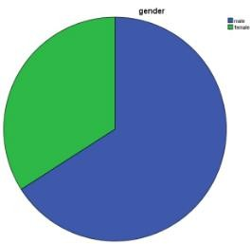

ANALYISIS: The given figure indicates the percentage of the male and female who contributed to the survey. In which male contribution indicate the percentage of 66% (93 out of 141) and female contribution indicate 34 %( 48 out of 141)
4.2DEPARTMENT OF THE RESPONDENTS:
Department
 | Frequency | Percent | Valid Percent | Cumulative Percent
Valid Hr | 17 | 12.1 | 12.1 | 12.1
Finance | 31 | 22.0 | 22.0 | 34.0
Marketing | 26 | 18.4 | 18.4 | 52.5
supply chain | 27 | 19.1 | 19.1 | 71.6
Production | 40 | 28.4 | 28.4 | 100.0
Total | 141 | 100.0 | 100.0

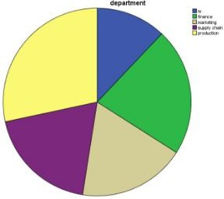

ANALYSIS: The given figure indicates the percentage of the various department who has contributed to the survey .In which the department human resource has contributed of 12.1%(17 out of 141) finance contribution to the survey is 22%(31 out of 141)marketing contribution of 18.4%(26 out of 141)supply chain contribution of 19.1%(27 out of 141) and production contribution of 28.4%(40 out of 141)

4.3AGE OF THE RESPONDENTS:

Age
 |  | Frequency | Percent | Valid Percent | Cumulative Percent
Valid | 21-25 | 28 | 19.9 | 19.9 | 19.9
 | 26-30 | 59 | 41.8 | 41.8 | 61.7
 | 31-35 | 39 | 27.7 | 27.7 | 89.4
 | 36-40 | 9 | 6.4 | 6.4 | 95.7
 | above40 | 6 | 4.3 | 4.3 | 100.0
 | Total | 141 | 100.0 | 100.0

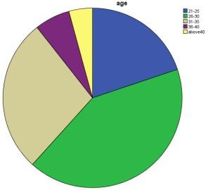
ANALYSIS: The given figure indicated the different age group of people who answered to the survey. In which 21-25 range are of people of 19.9 %( 28 out 141), 26-30 range of people are of 41.8% (59 out of 141), 31-35 range of people are of 27.7(39 out of 141), 36-40 range of people are of 6.4% (9 out of 141) and above 40 with the percentage of 4.3%(6 out of 141) respectively.

4.4 EXPERIENCE OF THE RESPONDENTS:
Experience

 | Frequency | Percent | Valid Percent | Cumulative Percent
Valid only one | 46 | 32.6 | 32.6 | 32.6
Two | 65 | 46.1 | 46.1 | 78.7
Three | 24 | 17.0 | 17.0 | 95.7
above 4 | 6 | 4.3 | 4.3 | 100.0
Total | 141 | 100.0 | 100.0

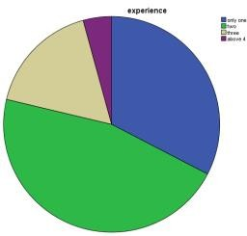
ANALYSIS: The give figure indicates the experience of the respondents. In which people with one year experience percentage is 32.6 %( 46 out 141) people with two year experience percentage is 46.1 %( 65 out of 141) people with three year experience percentage is 17% ( 24 out of 141) and above four years of experience percentage is 4.3(6 out of 141)

4.5HEALTH OF THE RESPONDENTS :

Health has not suffered
 |  | Frequency | Percent | Valid Percent | Cumulative Percent
Valid | neutral | 17 | 12.1 | 12.1 | 12.1
 | agree | 104 | 73.8 | 73.8 | 85.8
 | strongly agree | 20 | 14.2 | 14.2 | 100.0
 | Total | 141 | 100.0 | 100.0

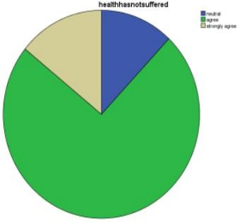

ANALYSIS: The given figure indicates the health condition of the respondents. In which people says that their health has not suffered working for this organization .out of 141 respondents the majority are agreed with the percentage of 73.8%(104 out of 141) some are strongly agreed with the percentage of 14.2%(20 out of 141) and remaining are neutral with 12.1%(17 out of 141)

4.6HEALTH AND SAFETY OF RESPONDENTS:

Health and safety

 |  | Frequency | Percent | Valid Percent | Cumulative Percent
Valid | neutral | 7 | 5.0 | 5.0 | 5.0
 | agree | 116 | 82.3 | 82.3 | 87.2
 | strongly agree | 18 | 12.8 | 12.8 | 100.0
 | Total | 141 | 100.0 | 100.0

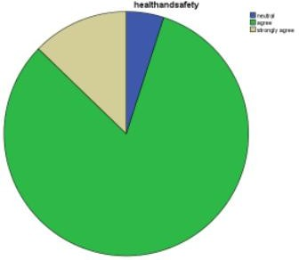

ANALYSIS: The given figure represents the health and safety of the respondents. In which out of 141 respondents majority of people agreed with the percentage of 82.3%(116 out of 141) some strongly agreed with 12.8%(18 out of 141) and remaining people are neutral with5.0%(7 out of 141)

4.7 RECRUITMENT AND SELECTION OF THE RESPONDENTS:

Recruitment and selection

 | Frequency | Percent | Valid Percent | Cumulative Percent
Valid neutral | 1 | .7 | .7 | .7
Agree | 88 | 62.4 | 62.4 | 63.1
strongly agree | 52 | 36.9 | 36.9 | 100.0
Total
 | 141 | 100.0 | 100.0

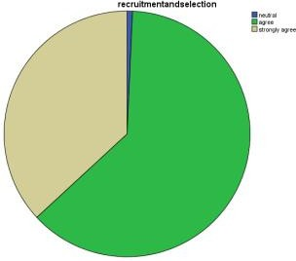

ANALYSIS: The given figure indicates the recruitment and selection of the respondents .In which out of 141 respondents 88 of them strongly agreed with the percentage of 62.4%(88 out of 141), 52 of them agreed with percentage of 36.9%(52 out of 141) and only stated neutral.

4.8FAVOURITISM OF THE RESPONDENTS:

Favoritism

 | Frequency | Percent | Valid Percent | Cumulative Percent
Valid neutral | 2 | 1.4 | 1.4 | 1.4
Agree | 40 | 28.4 | 28.4 | 29.8
strongly agree | 99 | 70.2 | 70.2 | 100.0
Total | 141 | 100.0 | 100.0
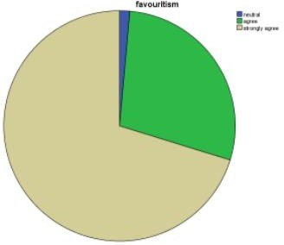

ANALYSIS: The given figure represents the favoritism of the respondents. In which out of 141 respondents majority of them strongly agreed with the percentage of 70.2%(99 out of 141) some of them agreed with the percentage of 28.4%(40 out of 141) and two of them answered neutral with 1.4%(2 out of 141).
4.9INTERVIEW PANELS OF THE RESPONDENTS:

Interview panels

 | Frequency | Percent | Valid Percent | Cumulative Percent
Valid Agree | 21 | 14.9 | 14.9 | 14.9
strongly agree | 120 | 85.1 | 85.1 | 100.0
Total | 141 | 100.0 | 100.0

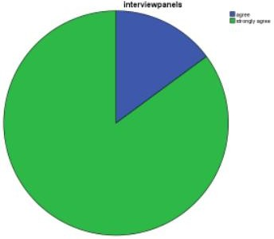

ANALYSIS: The given figure indicates the job definition of the organization of the respondents.in which out of 141 respondents of 120 of them strongly agree with the percentage of 85.1%(120 out of 141), 21 of them agree with the percentage of 14.9%(21 out of 140).

4.10ATTENTION OF THE RESPONDENTS:

Pay more attention

 |  | Frequency | Percent | Valid Percent | Cumulative Percent
Valid | Agree
 |  | 99 | 70.2 | 70.2 | 70.2
 | strongly agree
 |  | 42 | 29.8 | 29.8 | 100.0
 | Total
 |  | 141 | 100.0 | 100.0

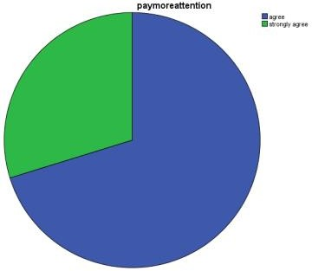

ANALYSIS: The given figure indicates attention for the respondents.in which out of 141 respondents of 42 of them strongly agree with the percentage of 29.8%(42 out of 141), 99 of them agree with the percentage of 70.2%(99 out of 141)

4.11EMPLOYERS SUPPORT OF THE RESPONDENTS:

Employer supports employee

 | Frequency | Percent | Valid Percent | Cumulative Percent
Valid neutral | 1 | .7 | .7 | .7
Agree | 40 | 28.4 | 28.4 | 29.1
strongly agree | 100 | 70.9 | 70.9 | 100.0
Total | 141 | 100.0 | 100.0
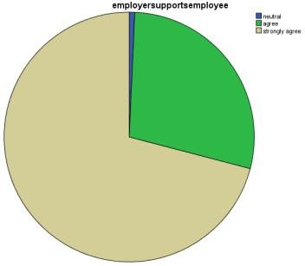

ANALYSIS: The given figure indicates the employers supports employee of the respondents.in which out of 141 respondents of 100 of them strongly agree with the percentage of 70.9%(100 out of 141), 40 of them agree with the percentage of 28.4%(40 out of 141) and only one stated neutral

4.12EQUALITY IF THE RESPONDENTS:

Men and women
 |  | Frequency | Percent | Valid Percent | Cumulative Percent
Valid | Disagree | 2 | 1.4 | 1.4 | 1.4
 | Neutral | 16 | 11.3 | 11.3 | 12.8
 | Agree | 116 | 82.3 | 82.3 | 95.0
 | strongly agree | 7 | 5.0 | 5.0 | 100.0
 | Total | 141 | 100.0 | 100.0

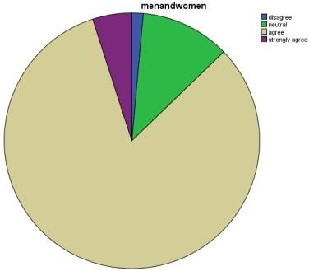

ANALYSIS: The given figure indicates the men and women of the respondents.in which out of 141 respondents of 7 of them strongly agree with the percentage of 5.0%(7 out of 141), 116 of them agree with the percentage of 82.3%(116 out of 141) and 16 of them stated neutral and 2 of them disagreed to the statement

4.13ENCOURAGEMENT OF THE RESPONDENTS:

Encourages me to extend my abilities

 |  | Frequency | Percent | Valid Percent | Cumulative Percent
Valid | Neutral | 11 | 7.8 | 7.8 | 7.8
 | Agree | 123 | 87.2 | 87.2 | 95.0
 | strongly agree | 7 | 5.0 | 5.0 | 100.0
 | Total | 141 | 100.0 | 100.0

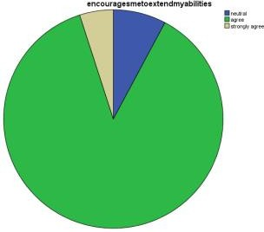

ANALYSIS: The given figure indicates the encourages me to extend abilities of the respondents in which out of 141 respondents of 7 of them strongly agree with the percentage of 5.0%(7 out of 141), 123 of them agree with the percentage of 87.2%(123 out of 141) and 11 of them stated neutral

4.14TRAINING OPPORTUNITIES OF THE RESPONDENTS:

Training opportunities
 |  | Frequency | Percent | Valid Percent | Cumulative Percent
Valid | Neutral | 6 | 4.3 | 4.3 | 4.3
 | Agree | 110 | 78.0 | 78.0 | 82.3
 | strongly agree | 25 | 17.7 | 17.7 | 100.0
 | Total | 141 | 100.0 | 100.0

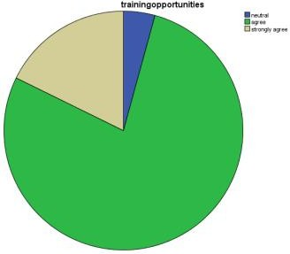

ANALYSIS: The given figure indicates the training opportunities of the respondents in which out of 141 respondents of 25 of them strongly agree with the percentage of 17.7%(25 out of 141), 110 of them agree with the percentage of 78.0%(110 out of 141) and 6 of them stated neutral

4.15 TRAINING AND DEVELOPMENT OF THE RESPONDENTS:

Training and development

 | Frequency | Percent | Valid Percent | Cumulative Percent
Valid neutral | 1 | .7 | .7 | .7
Agree | 42 | 29.8 | 29.8 | 30.5
strongly agree | 98 | 69.5 | 69.5 | 100.0
Total | 141 | 100.0 | 100.0

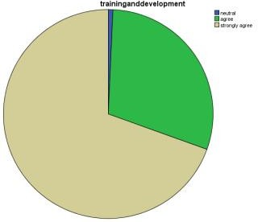

ANALYSIS: The given figure indicates the training and development in the organization of the respondents.in which out of 141 respondents of 98 of them strongly agree with the percentage of 69.5%(98 out of 141), 42 of them agree with the percentage of 29.8%(42 out of 141) and 7 stated neutral

4.16ORGANIZATION COMMITMENT OF THE RESPONDENTS:

Organization is committed

 | Frequency | Percent | Valid Percent | Cumulative Percent
Valid neutral | 7 | 5.0 | 5.0 | 5.0
Agree | 114 | 80.9 | 80.9 | 85.8
strongly agree | 20 | 14.2 | 14.2 | 100.0
Total | 141 | 100.0 | 100.0

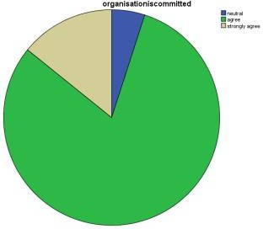

ANALYSIS: The given figure indicates the organization commitment to the respondents.in which out of 141 respondents of 20 of them strongly agree with the percentage of 14.2 %( 20 out of 141), 114 of them agree with the percentage of 80.9%(114 out of 141) and 7 of them stated neutral

4.17FAITH IN THE PERFORMANCE OF THE RESPONDENTS:

Faith in the performance
 |  | Frequency | Percent | Valid Percent | Cumulative Percent
Valid | Neutral | 18 | 12.8 | 12.8 | 12.8
 | Agree | 111 | 78.7 | 78.7 | 91.5
 | strongly agree | 12 | 8.5 | 8.5 | 100.0
 | Total | 141 | 100.0 | 100.0

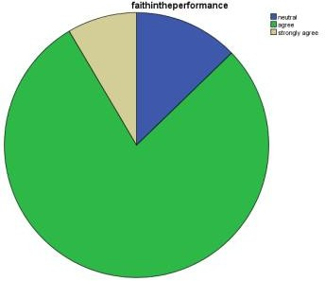

ANALYSIS: The given figure indicates the faith and performance of the respondents.in which out of 141 respondents of 12 of them strongly agree with the percentage of 8.5%(12 out of 141), 111 of them agree with the percentage of 78.7%(111 out of 141) and 18 of them stated neutral

4.18JOB DUTIES OF THE RESPONDENTS:

Job duties

 | Frequency | Percent | Valid Percent | Cumulative Percent
Valid disagree | 3 | 2.1 | 2.1 | 2.1
Neutral | 34 | 24.1 | 24.1 | 26.2
Agree | 80 | 56.7 | 56.7 | 83.0
strongly agree | 24 | 17.0 | 17.0 | 100.0
Total | 141 | 100.0 | 100.0
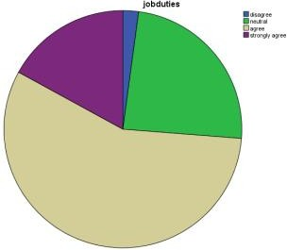

ANALYSIS: The given figure indicates the job duties of the respondents.in which out of 141 respondents of 24 of them strongly agree with the percentage of 17.0%(24 out of 141), 80 of them agree with the percentage of 56.7%(80 out of 141) 34 stated neutral with the percentage of 24.1% and 3 disagreed to the statement.

4.19COMPENSATION OF THE RESPONDENTS:

Compensation

 | Frequency | Percent | Valid Percent | Cumulative Percent
Valid neutral | 28 | 19.9 | 19.9 | 19.9
Agree | 78 | 55.3 | 55.3 | 75.2
strongly agree | 35 | 24.8 | 24.8 | 100.0
Total | 141 | 100.0 | 100.0

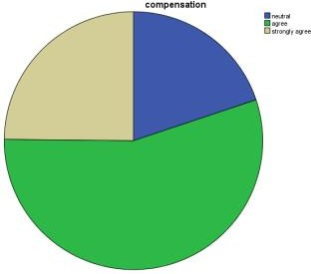

ANALYSIS: The given figure indicates the compensation of the respondents in which out of 141 respondents of 35 of them strongly agree with the percentage of 24.8%(35 out of 141), 78 of them agree with the percentage of 55.3%%(78 out of 141) and o28 of them stated neutral with percentage of 19.9%.
4.20INCENTIVE COMPENSATION OF RESPONDENTS:

Incentive compensation of employee

 | Frequency | Percent | Valid Percent | Cumulative Percent
Valid Neutral | 10 | 7.1 | 7.1 | 7.1
Agree | 85 | 60.3 | 60.3 | 67.4
strongly agree | 46 | 32.6 | 32.6 | 100.0
Total | 141 | 100.0 | 100.0

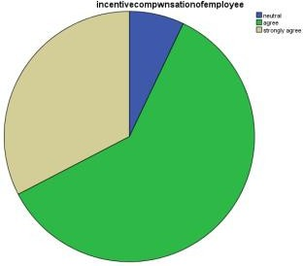

ANALYSIS: The given figure indicates the incentive compensation of employee of the respondents.in which out of 141 respondents of 46 of them strongly agree with the percentage of 32.6%(46 out of 141), 85 of them agree with the percentage of 60.3%(85 out of 141) and 10 of them stated neutral

4.21 JOB DEFINITION OF THE RESPONDENTS:

Job are clearly defined in our organization
 |  | Frequency | Percent | Valid Percent | Cumulative Percent
Valid | Disagree | 1 | .7 | .7 | .7
 | Neutral | 12 | 8.5 | 8.5 | 9.2
 | Agree | 80 | 56.7 | 56.7 | 66.0
 | strongly agree | 48 | 34.0 | 34.0 | 100.0
 | Total | 141 | 100.0 | 100.0
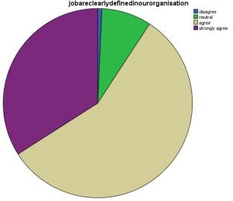

ANALYSIS: The given figure indicates the job clearly define our organization of the respondents.in which out of 141 respondents of 48 of them strongly agree with the percentage of 34.0%(48 out of 141), 80 of them agree with the percentage of 56.7%(80 out of 141) and 12 of them stated neutral and one stated disagreed

4.22APPRAISAL SYSTEM OF THE RESPONDENTS:

Appraisals system in our organization is growth and development

 |  | Frequency | Percent | Valid Percent | Cumulative Percent
Valid | Neutral | 18 | 12.8 | 12.8 | 12.8
 | Agree | 80 | 56.7 | 56.7 | 69.5
 | strongly agree | 43 | 30.5 | 30.5 | 100.0
 | Total
 |  | 141 | 100.0 | 100.0
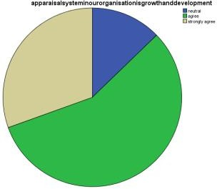

ANALYSIS: The given figure indicates the appraisals system in our organizations growth and development of the respondents.in which out of 141 respondents of 43 of them strongly agree with the percentage of 30.5%(43 out of 141), 80 of them agree with the percentage of 56.7%(80 out of 144) and 18 of them stated neutral

4.23FEEDBACK AND COUNSELLING OF THE RESPONDENTS:

Feedback and counseling

 | Frequency | Percent | Valid Percent | Cumulative Percent
Valid Neutral | 11 | 7.8 | 7.8 | 7.8
Agree | 93 | 66.0 | 66.0 | 73.8
strongly agree | 37 | 26.2 | 26.2 | 100.0
Total | 141 | 100.0 | 100.0

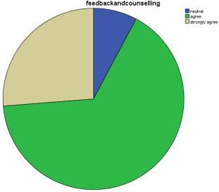

ANALYSIS: The given figure indicates the feedback and counseling of the respondents.in which out of 141 respondents of 37 of them strongly agree with the percentage of 26.2%(37 out of 141), 93 of them agree with the percentage of 66%(93 out of 141) and 11 of them stated neutral
STASTICAL ANALYSIS
4.24 ANOVA

Gender
 | Sum of Squares | df | Mean Square | F | Sig.
Between Groups
 | 1.429 | 3 | .476 | 2.159 | .096
Within Groups | 30.230 | 137 | .221
Total
 | 31.660 | 140

ANALYSIS:
H1: There is no significance difference between gender and working condition.
H2: There is a significance difference between gender and working condition.
The probability value in the ANOVA table is 0.096 respectively. It is more than 0.05. Hence, at 95% confidence level, H1 are accepted. Thus, there is a significant variation between gender and working condition.

4.25 CORRELATIONS:
Correlations

 |  | Training | Employee performa  nce | Employee participatio  n | Working condition | impartial ity | Employee motivation | Job definition | Working environme  nt
training | Pearson Correlation | 1 | .042 | .066 | .110 | .017 | .164 | .072 | .095
 | Sig. (2  tailed) |  | .625 | .436 | .193 | .838 | .052 | .396 | .261
 | N | 141 | 141 | 141 | 141 | 141 | 141 | 141 | 141
Employee performance | Pearson Correlation Sig. (2 tailed)  N | .042 | 1 | .278** | .146 | .152 | .119 | .044 | .016
Employee performance | Pearson Correlation Sig. (2 tailed)  N | .625 |  | .001 | .084 | .071 | .158 | .606 | .851
Employee performance | Pearson Correlation Sig. (2 tailed)  N | 141 | 141 | 141 | 141 | 141 | 141 | 141 | 141
Employee participation | Pearson Correlation | .066 | .278** | 1 | .146 | .415** | .069 | .085 | .045
 | Sig. (2  tailed) | .436 | .001 |  | .083 | .000 | .415 | .317 | .597
 | N | 141 | 141 | 141 | 141 | 141 | 141 | 141 | 141
Working condition | Pearson Correlation | .110 | .146 | .146 | 1 | .303** | .516** | .035 | .154
 | Sig. (2  tailed) | .193 | .084 | .083 |  | .000 | .000 | .676 | .068
 | N | 141 | 141 | 141 | 141 | 141 | 141 | 141 | 141
Impartiality | Pearson Correlation | .017 | .152 | .415** | .303** | 1 | .304** | .114 | .013
 | Sig. (2  tailed) | .838 | .071 | .000 | .000 |  | .000 | .179 | .879
 | N | 141 | 141 | 141 | 141 | 141 | 141 | 141 | 141
Employee motivation | Pearson Correlation Sig. (2 tailed)  N | .164 | .119 | .069 | .516** | .304** | 1 | .227** | .125
Employee motivation | Pearson Correlation Sig. (2 tailed)  N | .052 | .158 | .415 | .000 | .000 |  | .007 | .141
Employee motivation | Pearson Correlation Sig. (2 tailed)  N | 141 | 141 | 141 | 141 | 141 | 141 | 141 | 141

Job definition | Pearson Correlation | .072 | .044 | .085 | .035 | .114 | .227** | 1 | .178*
 | Sig. (2  tailed) | .396 | .606 | .317 | .676 | .179 | .007 |  | .034
 | N | 141 | 141 | 141 | 141 | 141 | 141 | 141 | 141
Working environment | Pearson Correlation | .095 | .016 | .045 | .154 | .013 | .125 | .178* | 1
 | Sig. (2  tailed) | .261 | .851 | .597 | .068 | .879 | .141 | .034
 | N | 141 | 141 | 141 | 141 | 141 | 141 | 141 | 141

**. Correlation is significant at the 0.01 level (2 tailed).

*. Correlation is significant at the 0.05 level (2 tailed).
INTERPRETATION:
The Pearson correlation value between employee performance and employee participation is
0.278 which is weekly positively correlated
The Pearson correlation value employee participation and impartiality is 0.415 which is moderately positively correlated
The Pearson correlation value working condition and impartiality is 0.303 which is moderately positively correlated
The Pearson correlation value working condition and employee motivation is 0.516 which is moderately positively correlated
The Pearson correlation value impartiality and employee motivation is 0.304 which is moderately positively correlated
The Pearson correlation value employee motivation and job definition is 0.227 which is weekly positively correlated
The Pearson correlation value impartiality and employee motivation is 0.304 which is moderately positively correlated
The Pearson correlation value impartiality and employee motivation is 0.304 which is moderately positively correlated
The Pearson correlation value job definition and working environment is 0.178 which is weekly positively correlated

H1: There is a relationship between employee performance and employee participation.

The significance value of correlation between employee performance and employee participation is less than 0.05 which statically significant. The Pearson correlation value is reported at 0.278. The relationship is weekly positive.

Hence H1 is accepted.

H2: There is a relationship between employee participation and impartiality

The significance value of correlation between employee participation and impartiality is less than
0.05 which statically significant. The Pearson correlation value is reported at 0.415.The relationship is moderately positive.

Hence H2 is accepted.

H3: There is a relationship between working condition and impartiality

The significance value of correlation between working condition and impartiality is less than
0.05 which statically significant. The Pearson correlation value is reported at 0.303. The relationship is moderately positive.

Hence H3 is accepted.

H4: There is a relationship between working condition and employee motivation

The significance value of correlation between working condition and employee motivation is less than 0.05 which statically significant. The Pearson correlation value is reported at 0.516. The relationship is moderately positive.
Hence H4 is accepted.

H5: There is a relationship between impartiality and employee motivation

The significance value of correlation between impartiality and employee motivation is less than
  - Which statically significant. The Pearson correlation value is reported at 0.304. The relationship is moderately positive.

Hence H5 is accepted.

H6: There is a relationship between employee motivation and job definition

The significance value of correlation between employee motivation and job definition is less than 0.05 which statically significant. The Pearson correlation value is reported at 0.227. The relationship is weekly positive.

Hence H6 is accepted.

H7: There is a relationship between working environment and job definition

The significance value of correlation between working environment and job definition is less than 0.05 which statically significant. The Pearson correlation value is reported at 0.178. The relationship is weekly positive.

Hence H7 is accepted.

4.26REGRESSION:
COFFICIENTS
Model | Unstandardized Coefficients |  | Standardized Coefficients | t | Sig.
Model | B | Std. Error | Beta | t | Sig.
1 (Constant) | 1.411 | 2.299 |  | .614 | .541
Training | .144 | .073 | .140 | 1.986 | .049
Employee performance | .045 | .077 | .042 | .581 | .563
Employee participation | -.079 | .063 | -.098 | -1.247 | .215
Working condition | .551 | .097 | .426 | 5.693 | .000
Impartiality | .245 | .104 | .187 | 2.359 | .020
Job definition | .231 | .072 | .228 | 3.209 | .002
Working environment | .191 | .114 | .121 | 1.674 | .096
a. Dependent Variable: employee motivation
INTERPRETATION:
Working condition as the influential factor on employee motivation. It has a significant value of
0.000 Which is less than the accepted value of 0.05 and with the beta value of .426 and t- statistical value of 5.693.

Job definition as another influential factor on employee motivation .It has a significant value of
0.02 Which is less than the accepted value of 0.05 and with the beta value .228 and t-statistical value of 3.209. While all other variables are insignificant values which is greater than 0.05

CHAPTER-5

FINDINGS:
- According to the study it is analyzed that male contributed to the percentage of 66% (93 out of 14) and female contributed to the percentage of 34 %( 48 out of 141). This show that male are dominant to women when compared.
- According to the study it is analyzed the department human resource has contributed of 12.1%(17 out of 141) finance contribution to the survey is 22%(31 out of 141)marketing contribution of 18.4%(26 out of 141)supply chain contribution of 19.1%(27 out of 141) and production contribution of 28.4%(40 out of 141)
- According to the study it is analyzed the different age group of people who answered to the survey varies accordingly. In which 21-25 range are of people of 19.9%(28 out 141),26-30 range of people are of 41.8%(59 out of 141), 31-35 range of people are of 27.7(39 out of 141), 36-40 range of people are of 6.4%(9 out of 141) and above 40 with the percentage of 4.3%(6 out of 141)
- According to the study it is analyzed the experience of the respondents with one year experience percentage is 32.6%(46 out 141)people with two year experience percentage is 46.1%(65 out of 141) people with three year experience percentage is 17%(24 out of 141) and above four years of experience percentage is 4.3(6 out of 141)
- According to the study it is analyzed the health condition of the respondents says that their health has not suffered working for this organization. The majority are agreed with the percentage of 73.8%(104 out of 141) some are strongly agreed with the percentage of 14.2%(20 out of 141) and remaining are neutral with 12.1%(17 out of 141)
- According to the study it is analyzed the health and safety of the respondents is not affected working for this organization. Majority of people agreed with the percentage of 82.3%(116 out of 141) some strongly agreed with 12.8%(18 out of 141) and remaining people are neutral with5.0%(7 out of 141)
- According to the study it is analyzed the recruitment and selection of the respondents is better. In which out of 141 respondents 88 of them strongly agreed with the percentage of 62.4% (88 out of 141), 52 of them agreed with percentage of 36.9% (52 out of 141) and only stated neutral

- According to the study it is analyzed the favoritism in the organization is less. out of 141 respondents majority of them strongly agreed with the percentage of 70.2%(99 out of 141) some of them agreed with the percentage of 28.4%(40 out of 141) and two of them answered neutral with 1.4%(2 out of 141)
- According to the study it is analyzed the job definition of the organization of the respondents is very good. Out of 141 respondents of 120 of them strongly agree with the percentage of 85.1% (120 out of 141), 21 of them agree with the percentage of 14.9% (21 out of 140).
- According to the study it is analyzed attention for the employers is good. Out of 141 respondents of 42 of them strongly agree with the percentage of 29.8%(42 out of 141), 99 of them agree with the percentage of 70.2%(99 out of 141
- According to the study it is analyzed indicates the employers supports employee whenever required. Out of 141 respondents of 100 of them strongly agree with the percentage of 70.9%(100 out of 141), 40 of them agree with the percentage of 28.4%(40 out of 141) and only one stated neutral
- According to the study it is analyzed the men and women are with the difference and male employees seems to be higher when compared to female employees .Out of 141 respondents of 7 of them strongly agree with the percentage of 5.0%(7 out of 141), 116 of them agree with the percentage of 82.3%(116 out of 141) and 16 of them stated neutral and 2 of them disagreed to the statement
- According to the study it is analyzed employer encourages employee to exhibit their abilities. Out of 141 respondents of 7 of them strongly agree with the percentage of 5.0%(7 out of 141), 123 of them agree with the percentage of 87.2%(123 out of 141) and 11 of them stated neutral
- According to the study it is analyzed indicates the training opportunities in the organization is good. Out of 141 respondents of 25 of them strongly agree with the percentage of 17.7%(25 out of 141), 110 of them agree with the percentage of 78.0%(110 out of 141) and 6 of them stated neutral
- According to the study it is analyzed the training and development in the organization is efficient. Out of 141 respondents of 98 of them strongly agree with the percentage of 69.5%(98 out of 141), 42 of them agree with the percentage of 29.8%(42 out of 141) and 7 stated neutral

- According to the study it is analyzed that organizational commitment is good. Out of 141 respondents of 20 of them strongly agree with the percentage of 14.2 %( 20 out of 141), 114 of them agree with the percentage of 80.9%(114 out of 141) and 7 of them stated neutral
- According to the study it is analyzed the faith and performance of the respondents is average. Out of 141 respondents of 12 of them strongly agree with the percentage of 8.5%(12 out of 141), 111 of them agree with the percentage of 78.7%(111 out of 141) and 18 of them stated neutral
- According to the study it is analyzed the job duties are shaped by the employee than formal description is less .Out of 141 respondents of 24 of them strongly agree with the percentage of 17.0%(24 out of 141), 80 of them agree with the percentage of 56.7%(80 out of 141) 34 stated neutral with the percentage of 24.1% and 3 disagreed to the statement.
- According to the study it is analyzed the compensation of the respondents is good. In which out of 141 respondents of 35 of them strongly agree with the percentage of 24.8 %( 35 out of 141), 78 of them agree with the percentage of 55.3 %%( 78 out of 141) and o28 of them stated neutral with percentage of 19.9%.
- According to the study it is analyzed the incentive compensation of employee is good. In which out of 141 respondents of 46 of them strongly agree with the percentage of 32.6%(46 out of 141), 85 of them agree with the percentage of 60.3%(85 out of 141) and 10 of them stated neutral
- According to the study it is analyzed the job role are clearly defined in the organization of the respondents. In which out of 141 respondents of 48 of them strongly agree with the percentage of 34.0%(48 out of 141), 80 of them agree with the percentage of 56.7%(80 out of 141) and 12 of them stated neutral and one stated disagreed
- According to the study it is analyzed the appraisals system in our organizations growth and development oriented .In which out of 141 respondents of 43 of them strongly agree with the percentage of 30.5%(43 out of 141), 80 of them agree with the percentage of 56.7%(80 out of 144) and 18 of them stated neutral
- According to the study it is analyzed the feedback and counseling of the respondents is given when required. In which out of 141 respondents of 37 of them strongly agree with the percentage of 26.2%(37 out of 141), 93 of them agree with the percentage of 66%(93 out of 141) and 11 of them stated neutral

SUGGESTIONS:
Following are suggestions in which Performance feedback manager should meet exclusively with staff once in three months and give a feedback on the specific staff individuals execution and recommend upgrades that could be, made before the following gathering Clearly characterized desire from the staff administrators to make it unmistakable to representatives on what is normal from them all the time. Regular absenteeism-manager ought to complete a guiding with staff and see whether the representative has any complaints or employment disappointment which is causing the non-appearance. Defining career development objectives persuading staff by demonstrating to them what they are really going after and that they have a clear achievable career way with EMS
Rather than conducting performance appraisal as a yearly thing it can be changed to an on- going thing. Setting smart goals for staff this ought to be set in direct arrangement to Approved leave toward the start on the year to give staff leave frames that must be given back inside a given due date so that occasions won't influence the business and satisfactory staff to cover the move.
Always review Human resource systems and strategy to ensure it is in the updated form regarding the law and its reasonableness for HR. Training and development executives to recognize employee’s staff preparing and advancement needs and to work with HR office to guarantee these requirements are met. It is suggested that performance appraisal should be used to; determine the training needs of the employees. Employees who are performing well above the requirements of the position can be placed in a development program that will prepare them for promotion to a higher level.
It was found that HRM practices have a significant role on Organizational Commitment of Employees but there need to be improvement in the area like Training & Development, Compensation and Employee welfare for the best result in the development of organization. To avoid such gaps, Organization must have to take care of Employees are well Trained and also gets motivated for their performance in the right time. At the same time the organization to be on regular interval in which it should focus on productivity of the organization rather than enhancing employee’s skills only.

CONCLUSION:

From the above findings the relationships between the Top management and the employees have been maintained well and there is a good of collaboration between individual’s goals and the group goals. Also there is transparency maintained between the top management and the employees. Also the work culture prevailing in the organization enables the employees to be a part of it, work independently and achieve better results.
The tradition and rituals of the organization is well attended and maintained. The management provides welfare schemes for the family also which motivates all aspects of employee to work more for the organization. Employee concerned leaders extending cooperation to the members at all levels and the rest of them are found to be Task oriented leaders. Similarly, most of them are strongly in favor to work under an employee-centered leader. They feel to be taken care of by the employers.
Expanding diversified markets have a wide assortment of requirements and desires that must be comprehended by associations to wind up solid clients and colleagues. Hierarchical change is attempted to improve the execution of the association. Organizations that will not grasp change may vanish. Fruitful authoritative change requires top administration a reasonable clarification of how the thought about changes can assist representatives with doing their activity's all the more proficiently and improve their transporter. This examination inferred that workers disposition towards hierarchical change was both positive and negative. It is prescribed that top administration extend the base up correspondence, to include workers who have potential ability to impact the change procedure or to give genuine contribution to future choices.
A majority of the respondents are of the view that organization takes good care of the welfare measures. There is much collaboration between the group goals and the individual goals in the organization. On the basis of the above findings it can be concluded that the there is an effective HRM practices followed by the EMS where from the study the following suggestions can be even more efficient for the industrial development.

ANNEXURE - BIBLIOGRAPHY

- Keld Laursen , “ The Importance of Sectoral Differences in the Application of (Complementary) HRM Practices for Innovation Performance”,July 2001.

- Sohel ahmad, Roger.G.Schroeder ,“The impact of human resource management practices on operational performance: recognizing country and industry differences”,journal of operations management 21, jan 2002.
- Shay S. Tzafrir, The late Gedaliahu H. Harel, Yehuda Baruch, Shimon L. Dolan, (2004) "The consequences of emerging HRM practices for employees' trust in their managers", Personnel Review, Vol. 33 Issue: 6, september 2003.
- Shay S.Tzafrir, “The relationship between trust,HRM practices and firm performance” , the international journal of human resource management, September 2005.
- S.G.A. Smeenk, R.N. Eisinga, J.C. Teelken and J.A.C.M. Doorewaard, “The effects of HRM practices and antecedents on organizational commitment among university employees “international journal. Of Human Resource Management, December 2006.
- J. Gould-Williams & R.B. Mohamed, “A comparative study of the effects of ‘best practice’ HRM on worker outcomes in Malaysia and England local government”, international journal of human resource management, April 2010.
- Michelle Greenwood and E. Edward Freeman, “ethics and hrm”, business and professional ethics journal, January 2011.
- Shruti Lamba, Nirmala choudhary, “impact on organizational commitment of employees”, the international journey of advancement of research and technology, volume 2, issue April 2013.
- Fiona Edgar and Alan Geare ,“HRM practice and employee attitudes: different measures – different results “Department of Management, University of Otago, Dunedin, New Zealand, April 2005.
- Zubair Aslam Marwat ,Tahir Masood Qureshi ,Muhammad I Ramay, “Impact of human resource management(HRM) practices on employee performance”
- Dana B. Minbaeva Department of International Economics and Management, Copenhagen Business School, Copenhagen, Denmark, “HRM practices and MNC knowledge transfer”.

ANNEXURE – QUESTIONNAIRE:
HRM PRACTISES FOR INDUSTRIAL DEVELOPMENT
DEMOGRAPHIC PROFILE:

Gender:

Years of experience:

Age:
 | 21 – 25 | 26 - 30 | 31 - 35 | 36 - 40 | ABOVE 40
AGE

S.no | Questions | Strongly | Agree | Neutral | Disagree | Strongly
 |  | Agree |  |  |  | Disagree
1 | My working conditions here are good
2 | My health has not suffered as a result of working for this organization
3 | This organization does what it can to ensure the wellbeing of its employees
4 | This organization spends enough money on health and safety-related matters
5 | The recruitment and selection processes in this organization are impartial
6 | Favoritism is not evident in any of the recruitment decisions made here
7 | Interview panels are used during the recruitment and selection process in this organization
8 | This organization does not need to pay more attention to the way it  recruits people
9 | My employer supports employees with the balancing of work and family responsibilities
10 | Men and women have the same employment opportunities in this organization
11 | My employer encourages me to extend my abilities
12 | This organization has provided me with training opportunities enabling me to extend my range of skills and abilities
13 | I get the opportunity to discuss my training and development requirements with my employer
14 | This organization is committed to the training and development of its employees
15 | Employees have faith in the performance appraisal system
16 | The actual job duties are shaped more by the employee than by the formal job description
17 | The compensation for all employees is directly linked with to his\her performance
18 | Job performance is an important factor in determining incentive compensation of employees.
19 | The duties of every job are clearly defined in our organization
20 | Appraisal system in our organization is growth and development oriented
21 | Employees are provided performance based feedback and counseling

